**Project Design Phase-II**

**Data Flow Diagram & User Stories**

|  |  |
| --- | --- |
| **DATE:** | **26-06-2025** |
| **Team ID :** | **LTVIP2025TMID58052** |
| **Project Name :** | **LearnHub: Your Center for Skill Enhancement** |

**1. Data Flow Diagram (DFD) – Level 0 Context Diagram**

This Level 0 Context Diagram provides a high-level overview of the LearnHub Online Learning Platform, illustrating its main interactions with external entities.

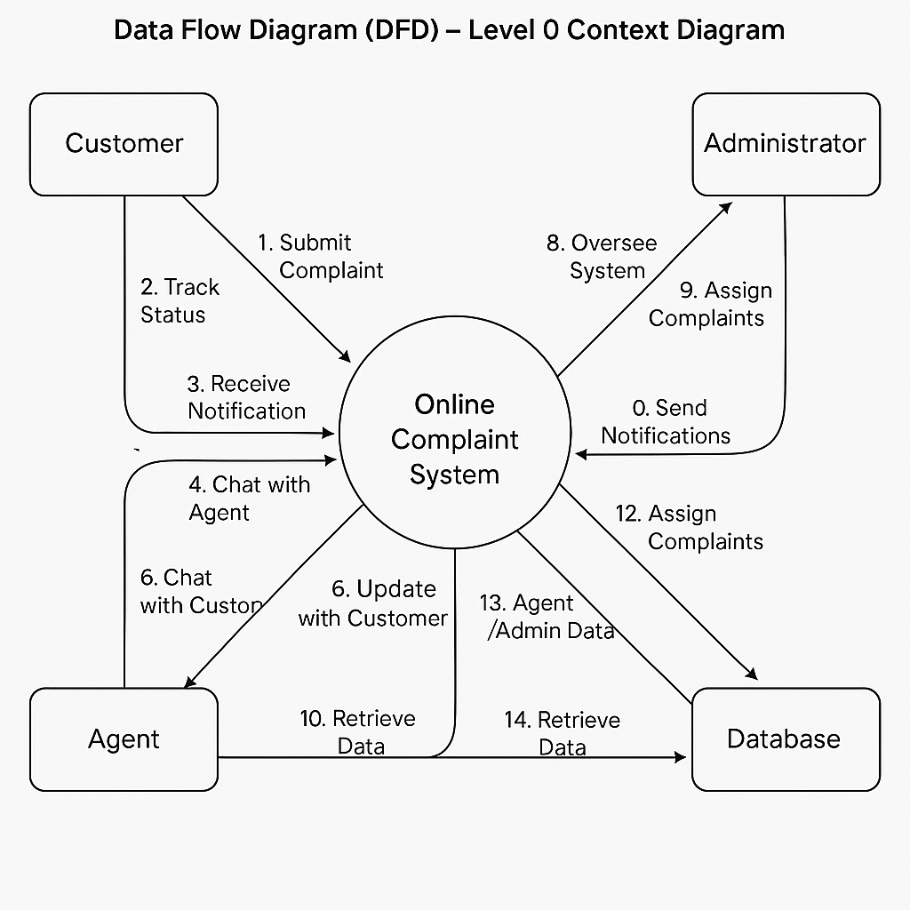

**Explanation of DFD Components:**

* Entities (Squares): External entities interacting with the system (Learner, Instructor, Administrator, Database).
* Process (Circle/Rounded Rectangle): The entire system treated as one process (LearnHub Platform).
* Data Flows (Arrows): Show the direction of data movement between entities and the system.

**Data Flows:**

1. Register/Login: Learner/Instructor/Admin sends credentials to the system.
2. Enroll in Course: Learner enrolls in courses.
3. Track Progress: Learner requests and receives progress updates.
4. Participate in Forum/Chat: Learner/Instructor sends and receives messages.
5. Upload Assignments: Learner uploads assignments.
6. Grade Assignments: Instructor grades assignments.
7. Manage Courses: Instructor/Admin creates and manages courses.
8. Oversee Platform: Admin accesses platform-wide reports and controls.
9. Notifications: System sends notifications to users.
10. Store User Data: System stores user profiles.
11. Store Course Data: System stores course details and materials.
12. Store Forum Data: System stores discussion data.
13. Retrieve Data: System fetches data from the database.

**2. User Stories**

User Stories translate functional requirements into concise, user-centric narratives, expressed in the format:

"As a [role], I want to [action] so that [benefit]."

Each story is testable via Acceptance Criteria.

| User Story ID | As a... | I want to... | So that... | Acceptance Criteria (Conditions of Satisfaction) |
| --- | --- | --- | --- | --- |
| US-FR1.1.1 | New Learner | register for an account securely | I can access LearnHub services | 1. Learner can navigate to a registration page. 2. Provides email, password, profile info. 3. Confirmation email sent securely. |
| US-FR1.1.2 | Registered User | log in to the platform | I can access my personalized dashboard | 1. Login page with email/password. 2. Successful login redirects to dashboard. 3. Incorrect credentials show error. |
| US-FR1.1.3 | User | reset my password | I can regain account access if forgotten | 1. "Forgot Password" option available. 2. Secure reset link sent via email. 3. User sets a new password. |
| US-FR1.1.4 | System User | access features based on my role | I see and perform actions relevant to me | 1. Learners see learner dashboard. 2. Instructors see instructor dashboard. 3. Admins see admin dashboard. |
| US-FR1.2.1 | Authenticated Learner | enroll in a course | I can start learning immediately | 1. Learner can view and enroll in available courses. 2. Enrollment confirmation shown. |
| US-FR1.2.2 | Authenticated Learner | upload assignments | Instructors can evaluate my work | 1. Learner can upload files in accepted formats. 2. Upload confirmation shown. |
| US-FR1.2.3 | Instructor | grade learner assignments | I can track and evaluate learner progress | 1. Instructor can view submissions. 2. Can provide grades and feedback. |
| US-FR1.2.4 | Instructor/Admin | create and manage courses | Learners have structured content to access | 1. Course creation form available. 2. Can upload materials and set details. |
| US-FR1.3.1 | Learner | track my course progress | I can monitor my learning goals | 1. Dashboard shows enrolled courses and progress bars. 2. Real-time updates reflected. |
| US-FR1.3.2 | Learner/Instructor | participate in forum discussions | I can collaborate and clarify doubts | 1. Discussion forums visible within courses. 2. Users can post and reply. |
| US-FR1.3.3 | Learner/Instructor | use in-app messaging | I can communicate directly without external tools | 1. Messaging feature integrated in course dashboard. 2. Real-time communication possible. |
| US-FR1.4.1 | Admin | oversee platform usage and data | I can maintain quality and security | 1. Admin dashboard displays user and course data. 2. Can manage user roles. |
| US-FR1.4.2 | System | send notifications to users | Users stay informed on key events | 1. Notifications sent on enrollments, updates, and grades. |
| US-FR1.5.1 | System | store and retrieve data reliably | Platform maintains accurate records | 1. User profiles, courses, forums, assignments stored securely. 2. Data retrieval is fast and accurate. |